**EXPERIMENT-6**

**DATE**:

**AIM**: To create a simple cloud software application for product selling using any cloud service provider to demonstrate SaaS.

**PROCEDURE**:

**step1**: Go to zoho.com.

**step 2**: Log into the zoho.com.

**step 3**: Select one application step.

**step4**: Enter application name as product selling.

**step 5**: Created new application as product selling.

**step 6**: Select one form

**step 7:** The software has been created.

**IMPLEMENTATION**:

**OUTPUT;**

**1.User Registration**

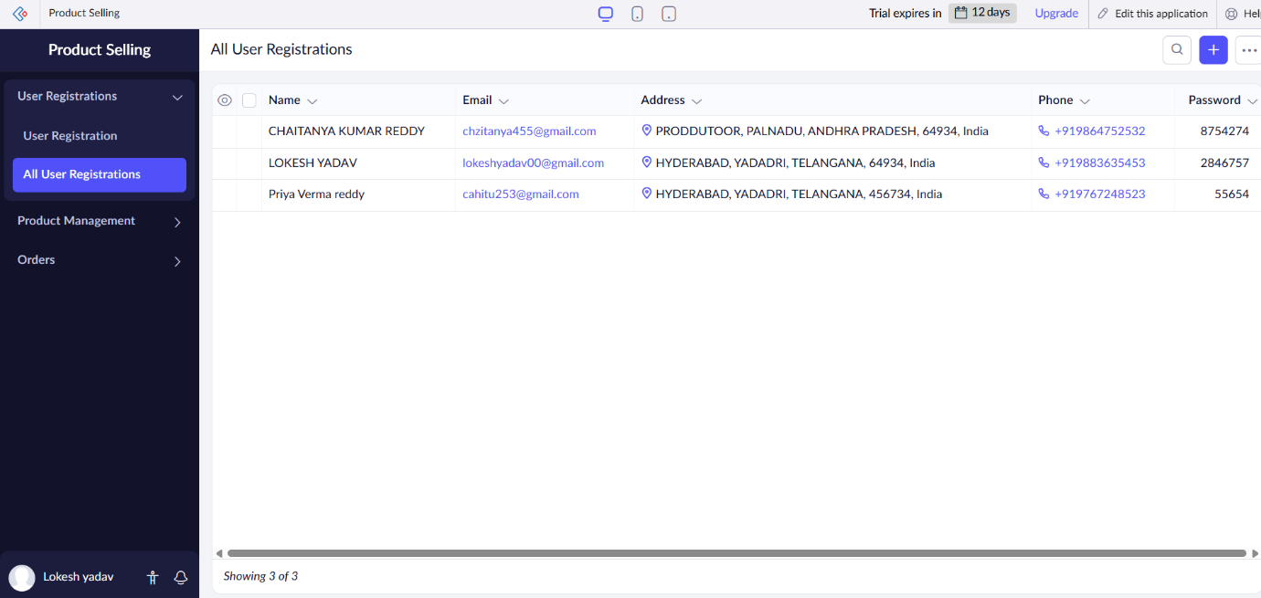

**2.Product Management**

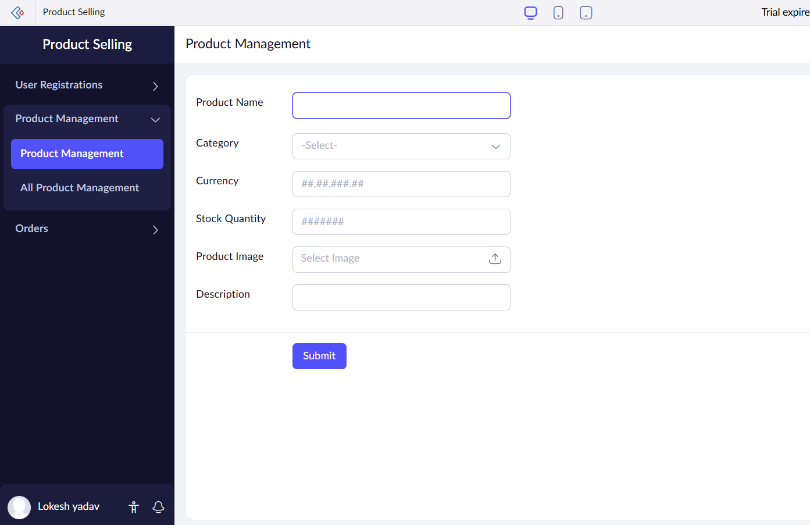

**3.Orders**

**RESULTS;** successfully implemented and developed the simple cloud software application for product selling using any cloud service provider to demonstrate SaaS.